Factors That Allow Life to Exist On Earth

- Proximity to the Sun Allowing Liquid Water:
One of the reasons that life is able to exist on Earth is the proximity, or distance, of the planet from the Sun. The Earth sits in the “habitable zone”, the “just right” area that provides a temperature that allows liquid water to exist. The area before the habitable zone, closer to the Sun, is too hot for liquid water to exist. It would boil and evaporate away. The area beyond the habitable zone would be too cold for liquid water, causing it to freeze. Life as we know it requires liquid water. Water exists in all forms on Earth: solid, liquid, and gas. We have a lot of water on Earth. In fact 70% of Earth’s surface is covered in liquid water. It is absolutely necessary for life as we know it, and the proximity to the Sun allows it to exist here.
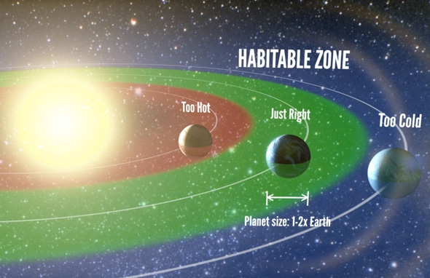

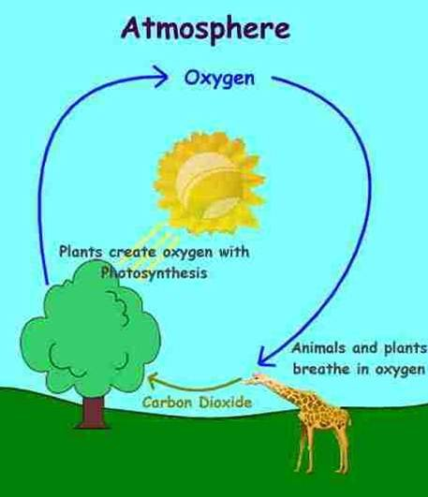
- Atmosphere:
The atmosphere, even though it is invisible, is vital to our survival on Earth. However, just because a planet has an atmosphere does not necessarily mean there will be life on it. Many of our solar system planets have atmospheres, but they are not suitable for life as we know it. In fact, many of the atmospheres of the other planets have poisonous gases that are harmful to life.
The atmosphere has many important jobs. First, it contains the “right” composition of gases including 78% nitrogen, 21% oxygen and trace amounts of carbon dioxide and other gases. Most living things on Earth require oxygen in order to produce energy needed to survive. The composition of gases in the atmosphere allows for gas exchange between plants and animals. Plants take carbon dioxide out of the atmosphere and put oxygen back in. Animals (and humans) breathe in oxygen and exhale carbon dioxide, putting it back into the air.

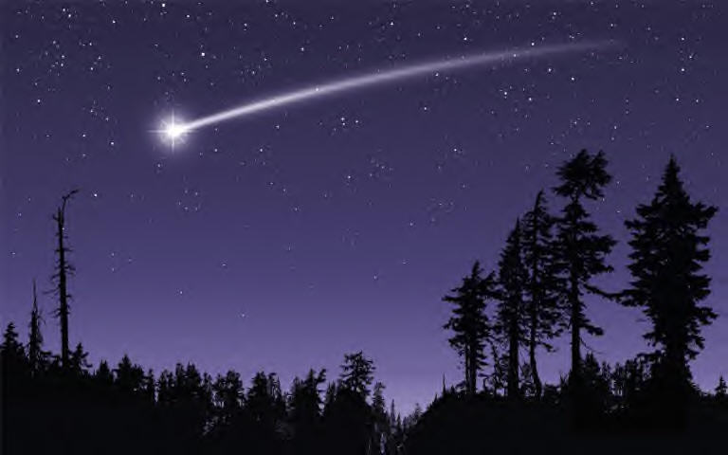
Next, the atmosphere protects against small to medium sized meteorite impacts. Have you ever seen a shooting star? It is not actually a star at all! It is actually a meteor that has entered Earth’s atmosphere, then it is called a meteoroid, and is moving at such a fast speed that the friction between the object and the atmosphere is causing it to burn up! While the atmosphere does protect us from A LOT of space junk, it does NOT protect us from ALL of it. Space debris falls to Earth every day, it just may be as small as a grain of sand. Most meteorites fall without anyone observing them hitting Earth’s surface. However, in 2013, citizens of Russia observed a large chunk of a meteorite crash into a lake. This meteor was only 19 meters wide, but it burst with the force of about 40 Hiroshima-type atom bombs, scientists say. It released a shock wave that shattered thousands of windows and injured more than 1,600 people, and its flash was bright enough to temporarily blind 70 people and cause dozens of skin-peeling sunburns just after dawn in icy Russia.
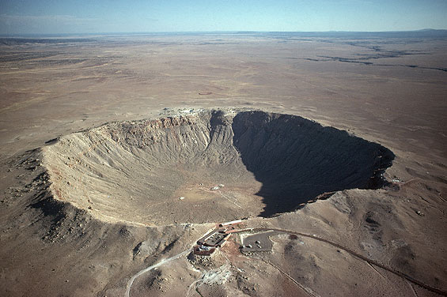

Impact crater located in Arizona

Another important job of the atmosphere is to regulate and keep temperatures stable. The greenhouse gases, such as carbon dioxide (small amounts) and water vapor, trap heat from the sun around Earth. The atmosphere is like a greenhouse. A greenhouse is a small building that usually has clear glass or plastic walls and a roof. In the winter, temperatures get below freezing, causing plants to die if they are not taken care of. People will place plants in the greenhouse so that they can still receive radiant energy from the Sun. The energy from the Sun gets trapped inside the greenhouse, causing the greenhouse to stay warm, even when it is cold outside. The atmosphere does a similar job, but it keeps the Earth warm at night when the Sun is not directly shining on it. This is known scientifically as the Greenhouse Effect.

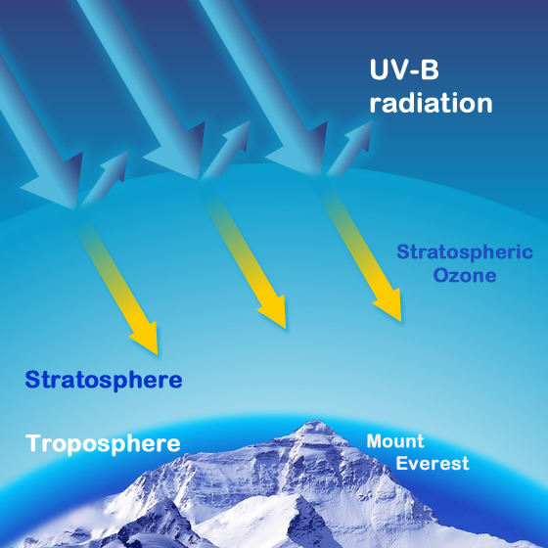
Although heat and light from the Sun make life possible on Earth, other forms of energy from the Sun threaten life on Earth. The greenhouse gases and the ozone layer protect the Earth from radiation and UV (ultraviolet) rays. The ozone layer is a thin concentration of ozone high in Earth's atmosphere. The molecules of ozone are made of 3 atoms of oxygen. The ozone layer is most concentrated about 23 km above Earth's surface. The atmospheric ozone layer protects life on Earth by absorbing ultraviolet radiation, especially a form called UVB. UVB causes sunburn, skin cancer, and cataracts in humans. As anyone who has suffered from sunburn knows, a lot of UVB radiation does get through the ozone layer. Without the ozone layer, however, even more harmful radiation would reach Earth's surface.

- Mass and Composition:
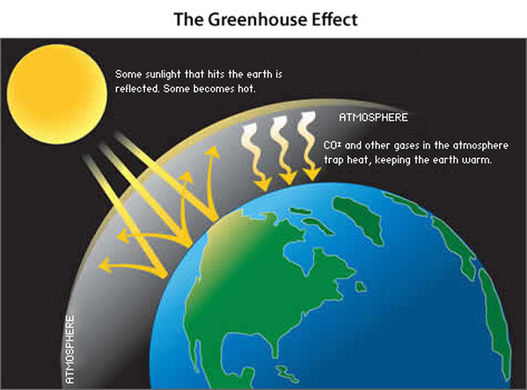
Given some recent studies of distant stars and the on-going discovery of exoplanets, many planets in the universe appear to be gas-giants similar to Saturn, Jupiter, Uranus and Neptune. The current science indicates that a rocky planet offers the best foundation for life and especially the diversity of life. The size or mass of the planet is also important. The mass of a planet determines the gravitational force. (Remember Sir Isaac Newton? We can thank him for discovering gravity!) The smaller the planet or moon, the smaller the force of gravity will be. Take our Moon for example. Our Moon is about 1/6 of the mass of Earth; therefore it has a gravitational pull of about 1/6 of Earth. The larger the planet or Moon, the larger the gravitational pull. You may be wondering what this has to do with life being able to exist. Do you remember all of the important jobs of the atmosphere that you just read about? If there is not enough gravity on the planet, it will not be able to hold onto the gases that make up the atmosphere. However, if the planet is too massive, think of Jupiter and Saturn, then the gravitational pull is so great that it will turn into a gas-giant! The mass of the planet has to be “just right” in order to hold the “just right” atmosphere for life as we know it!

4. Magnetosphere:
If you have used a compass, you know that Earth acts as if it had a bar magnet thrust through its center. The magnetized “needle" of a compass is attracted to Earth's magnetic north pole and points toward it. What you cannot see is the magnetic force produced by Earth's magnetism. This force forms a kind of magnetic blanket around the planet called the magnetosphere.
The magnetosphere begins about 1000 km above Earth's surface. On the side of Earth that faces the Sun, the magnetosphere reaches about 4000 km above Earth's surface. On the opposite side, the magnetosphere extends even farther out into space.
The magnetic force of an ordinary magnet captures iron filings. Similarly, Earth's magnetosphere captures some of the harmful charged particles that pour down on Earth from the Sun. The magnetosphere protects life on Earth by preventing these particles from reaching the planet's surface. The magnetosphere also protects life by preserving the oxygen in Earth's atmosphere.
This was discovered recently when scientists compared the effects of the Sun's radiation on the atmospheres of Earth and Mars. Oxygen was being lost at a far greater rate from the atmosphere of Mars than from the atmosphere of Earth. Mars has a much weaker magnetosphere than Earth has. The scientists concluded that the difference in the magnetic fields accounted for the differences in oxygen loss. The stronger the magnetic field, the less oxygen is lost.
